|  |  |  |  |
| --- | --- | --- | --- |
| **Name of Student: NINAD AVINASH PATIL** | | | |
| **Roll No: 33** | | **Lab Practical Number: 5(F)** | |
| **Title of Lab Practical: Website using Master Pages and Themes**  **1. Create master Page, two or three content pages. Use different themes for the home page and other pages. Master Page should contain tile of website (header), footer, Menu on left and advertisements on right.** | | | |
| **DOP: 21/04/2021** | | **DOS: 27/04/2021** | |
| **CO Mapped: CO1** | **PO Mapped: PO3, PO5, PO7,**  **PO12, PSO1, PSO2** | **Faculty Signature:** | **Marks:** |

**Practical No 5(F)**

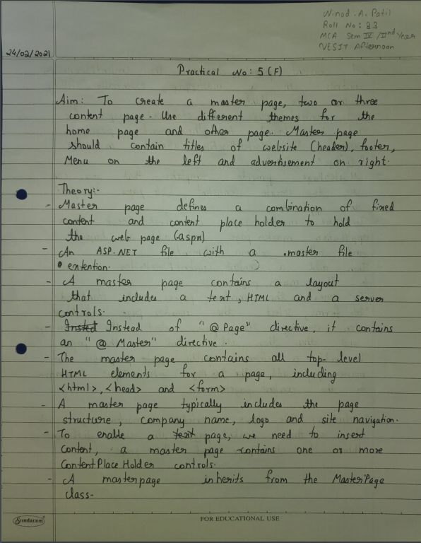

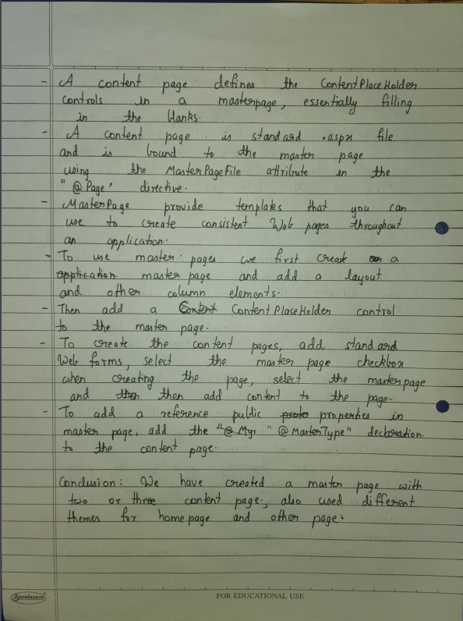

**Code:**

**MasterPage.master**

<%@ Master Language="C#" AutoEventWireup="true" CodeBehind="MasterPage.master.cs" Inherits="P5F.MasterPage" %>

<!DOCTYPE html PUBLIC "-//W3C//DTD XHTML 1.0 Transitional//EN" "http://www.w3.org/TR/xhtml1/DTD/xhtml1-transitional.dtd">

<html xmlns="http://www.w3.org/1999/xhtml">

<head id="Head1" runat="server">

<title>VESIT</title>

<asp:ContentPlaceHolder ID="head" runat="server">

</asp:ContentPlaceHolder>

<style type="text/css">

.header

{

height:53px;

font-size:xx-large;

text-align:center;

padding:5px;

background-color: #204a84;

color: #FFFFFF;

}

.main

{

width:auto;

height:510px;

padding:5px;

}

.left

{

float:left;

padding:5px;

width:200px;

height:510px;

font-size:x-large;

text-align:left;

}

.right

{

float:right;

padding:5px;

width:200px;

height:510px;

font-size:x-large;

}

.footer

{

height:53px;

text-align:center;

padding:5px;

}

</style>

</head>

<body>

<form id="form1" runat="server">

<div id="container">

<div class="header" align="center">

Welcome To Vivekanand Education Society's Institute Of Technology

</div>

<div class="left">

<div id="menu">

<asp:BulletedList ID="blstSample" runat="server" DisplayMode="HyperLink">

<asp:ListItem Value="Home.aspx">

Home

</asp:ListItem>

<asp:ListItem Value="AboutUs.aspx">

About Us

</asp:ListItem>

<asp:ListItem Value="Contact.aspx">

Contact Us

</asp:ListItem>

</asp:BulletedList>

</div>

</div>

<div class="right">

<asp:ContentPlaceHolder ID="sideContent" runat="server">

<p>default side content</p>

</asp:ContentPlaceHolder>

</div>

<div class="main">

<asp:ContentPlaceHolder ID="mainContent" runat="server">

<p>default main content</p>

</asp:ContentPlaceHolder>

</div>

<div class="footer" align="center">

<p>

&copy; 2021 All Rights Reserved

</p>

</div>

</div>

</form>

</body>

</html>

**Home.aspx**

<%@ Page Title="" Language="C#" MasterPageFile="~/MasterPage.Master" AutoEventWireup="true" CodeBehind="Home.aspx.cs" Inherits="P5F.Home" %>

<asp:Content ID="Content1" ContentPlaceHolderID="head" runat="server">

</asp:Content>

<asp:Content ID="Content2" ContentPlaceHolderID="sideContent" runat="server">

<asp:AdRotator BorderWidth="1" ID="MyAds" runat="server" Width="200px" Height="510px" Style="text-align: center" DataSourceID="adsOnWebsite" />

<asp:XmlDataSource ID="adsOnWebsite" runat="server" DataFile="~/Advertisements.xml">

</asp:XmlDataSource>

</asp:Content>

<asp:Content ID="Content3" ContentPlaceHolderID="mainContent" runat="server">

<p align="justify">

<b>Departments : </b>

<br />

<li><strong>AI and Data Science :</strong><br />

Artificial Intelligence, known as AI, and Data Science as DS, has become the two most important sought after technologies in today’s time. Artificial Intelligence and Data Science is everywhere and there is almost an urgent need to collect and preserve any data that is being generated. The department offers Bachelor of Engineering (B.E) program affiliated to Mumbai University. <br /><br />

<li><strong>Electronics Engineering :</strong><br />

The field related to the study of electronic devices and circuits their and their applications to solve real life problems effectively and efficiently. The department offers Bachelor of Engineering (B.E) program affiliated to Mumbai University. <br /><br />

<li><strong>Computer Engineering :</strong><br />

The department is committed towards imparting quality education and developing future technocrats in the stream of computers. The department offers Bachelor of Engineering (B.E) program affiliated to Mumbai University. <br /><br />

<li><strong>Instrumentation Engineering :</strong><br />

Field of Instrumentation is a rapidly expanding its boundaries to cater to the demanding applications.The scope of instrumentation has been further advanced by recent developments in field of MEMS and nanotechnology. <br /><br />

<li><strong>Electronics and Telecommunication Engineering :</strong><br />

The field is related to the application of electronics in the area to telecommunications. It aims to improve the overall efficiency at the same time reduce the cost associated with communication. The Department offers Bachelor of Engineering (B.E) and Master of Engineering (M.E.) programs affiliated to Mumbai University. <br /><br />

<li><strong>Information Technology :</strong><br />

With fast changing technology certain changes are essential. Considering these aspects, the Department of Information Technology aims at training the students to adapt themselves to the fast changing technology. The department offers Bachelor of Engineering (B.E) and Master of Engineering (M.E.) programs affiliated to Mumbai University. <br /><br />

<li><strong>Masters in Computer Application :</strong><br />

It is Three year Post-Graduate programme which focuses on advanced front line technology in the domain of Computer Application along with the required professional skill. MCA program is affiliated to the University of Mumbai.<br /><br />

<strong>V. E. S. Institute of Technology is also a recognized Ph.D. Centre to the University of Mumbai for faculty of Technology in Electronics Engineering.</strong></p>

</asp:Content>

**AboutUs.aspx**

<%@ Page Title="" Language="C#" MasterPageFile="~/MasterPage.Master" AutoEventWireup="true" CodeBehind="AboutUs.aspx.cs" Inherits="P5F.AboutUs" %>

<asp:Content ID="Content1" ContentPlaceHolderID="head" runat="server">

</asp:Content>

<asp:Content ID="Content2" ContentPlaceHolderID="sideContent" runat="server">

<asp:AdRotator BorderWidth="1"

ID="MyAds" runat="server" Width="200px"

Height="510px"

Style="text-align: center"

DataSourceID="adsOnWebsite" />

<asp:XmlDataSource ID="adsOnWebsite"

runat="server" DataFile="~/Advertisements.xml">

</asp:XmlDataSource>

</asp:Content>

<asp:Content ID="Content3" ContentPlaceHolderID="mainContent" runat="server">

<h2 align="center">ABOUT US</h2>

<hr />

<p align="justify">

Vivekanand Education Society was founded in 1959 by Shri. Hashu Advani, along with ten other members, who shared the dream of providing qualitative education to the youth of our country. In the beginning, Vivekanand Education Society had a very modest launch, with just 256 students and six classrooms, in the humble barracks of Chembur Camp. But today, it proudly boast of having 3, 75, 000 sq. ft. land, housing 12 buildings and 28 Institutions, ranging from a crèche to Ph.D. Centers. It has over 2000 teaching and non-teaching staff, and more than 18,000 students who pass through its hallowed portals each year.</p>

<p align="justify">

<br />

Vivekanand Education Society’s Institute of Technology (VESIT) was established in 1984, with the aim of providing professional education in the field of Engineering. This institute is affiliated to the University of Mumbai and follows

the rules and regulations laid down by government, AICTE, and University for admission; 51% reserved for Sindhi Linguistic minority and 49% through CAP test. The management quota has been surrendered to DTE to make admission centralized.

The institute has a total of 189 faculties, of which 21 are Ph.D. holders and 29 faculty members are pursuing their Ph.D.

</p>

</asp:Content>

**Contact.aspx**

<%@ Page Title="" Language="C#" MasterPageFile="~/MasterPage.Master" AutoEventWireup="true" CodeBehind="Contact.aspx.cs" Inherits="P5F.Contact" %>

<asp:Content ID="Content1" ContentPlaceHolderID="head" runat="server">

</asp:Content>

<asp:Content ID="Content2" ContentPlaceHolderID="sideContent" runat="server">

<asp:AdRotator BorderWidth="1" ID="MyAds" runat="server" Width="200px" Height="510px" Style="text-align: center" DataSourceID="adsOnWebsite" />

<asp:XmlDataSource ID="adsOnWebsite" runat="server" DataFile="~/Advertisements.xml">

</asp:XmlDataSource>

</asp:Content>

<asp:Content ID="Content3" ContentPlaceHolderID="mainContent" runat="server">

<h2 align="center">

CONTACT US</h2>

<hr />

<p align="center">

<b>Vivekanand Education Society’s Institute of Technology</b><br /> <br />

<b>Address:</b> Hashu Advani Memorial Complex,<br />

&nbsp;&nbsp;&nbsp;&nbsp;&nbsp;&nbsp;&nbsp;

Collector’s Colony,Chembur,<br /> &nbsp;&nbsp;

Mumbai – 400 074. India.<br /> <br />

<b>Tel.:</b> +91-22-61532510 / 27 (Admission)<br /> <br />

<b>Fax:</b> +91-22-61532555 <br /> <br />

<b>Email:</b> <a href="mailto:vesit@ves.ac.in">vesit@ves.ac.in</a><br />

&nbsp;&nbsp;&nbsp;&nbsp;&nbsp;&nbsp;&nbsp;&nbsp;&nbsp;&nbsp;&nbsp;&nbsp;&nbsp;&nbsp;&nbsp;&nbsp;&nbsp;&nbsp;&nbsp;&nbsp;&nbsp;&nbsp;&nbsp;&nbsp;&nbsp;&nbsp;

<a href="mailto:vesit.admission@ves.ac.in">vesit.admission@ves.ac.in</a><br />

&nbsp;&nbsp;&nbsp;&nbsp;&nbsp;&nbsp;&nbsp;&nbsp;&nbsp;&nbsp;&nbsp;&nbsp;&nbsp;&nbsp;&nbsp;&nbsp;&nbsp;&nbsp;&nbsp;&nbsp;&nbsp;&nbsp;&nbsp;

<a href="mailto:vesit.website@ves.ac.in">vesit.website@ves.ac.in</a></p>

</asp:Content>

**Advertisements.xml**

<?xml version="1.0" encoding="utf-8" ?>

<Advertisements>

<Ad>

<ImageUrl>~/mcd.jpg</ImageUrl>

<NavigateUrl>https://www.pepsi.com/</NavigateUrl>

<Impressions>20</Impressions>

<Keyword>foods</Keyword>

</Ad><Ad>

<ImageUrl>~/pepsi.jpg</ImageUrl>

<NavigateUrl>https://www.pepsi.com/</NavigateUrl>

<AlternateText>

Order Chilled Pepsi

</AlternateText>

<Impressions>20</Impressions>

<Keyword>softdrink</Keyword>

</Ad> <Ad>

<ImageUrl>~/sars.jpg</ImageUrl>

<NavigateUrl>https://www.talenthouse.com/</NavigateUrl>

<AlternateText>

Stay Home Stay Safe

</AlternateText>

<Impressions>20</Impressions>

<Keyword>house</Keyword>

</Ad>

</Advertisements>

**Output:**

